Temasek Polytechnic

School of Informatics and IT

**Diploma in Information Technology (IT)**

Assignment 1: TOR and Project Plan Report

**Project Particulars**

|  |  |
| --- | --- |
| **Tutor** | Mr Mel Goh |
| **Class** | P03 |
| **Project Title** | Delonix Regia Hotel Management System |

**Project Team’s Particulars**

|  |  |
| --- | --- |
| **Matric Number** | **Student Name** |
| **1405505G** | **Chia Yue Zhu Ameline** |
| **1400790J** | **Douglas Tan Jin Kun** |
| **1401279C** | **Muhammad Azrul B Mohd Sanif** |

**Table of Contents**

**1** **Term of Reference** 3

**1.1** **Introduction** 4

**1.2** **Objectives of the Project** 4

**1.3** **Scope of the Project** 4

**1.4** **Distribution of Workload** 5

**1.5** **Constraints** 6

**1.6** **Resources** 6

**1.7** **Product Positioning in the Market/Company** 7

**1.8** **Approach and Methodology of the Project** 8

**2** **Project Plan** 9

**2.1** **Introduction** 10

**2.1.1** **Objectives and scope of the project** 10

**2.1.2** **Assumptions and constraints** 11

**2.1.3** **Definitions and acronyms** 12

**2.2** **Roles and responsibilities** 12

**2.3** **Estimates and project schedule** 13

**2.3.1** **Work breakdown structure** 13

**2.3.2** **Project Schedule** 17

**2.3.3** **Budget Summary** 18

**2.3.4** **Risk Management Plan** 21

**3** **References** 23

# **Term of Reference**

## **Introduction**

The purpose of this project is to create and deploy a hotel management system that aids and provide a convenient platform for the hotel to run their business smoothly.

One of the problems faced is that Mr and Mrs Wang do not have a good management system therefore the business is not doing so well despite being in a relatively good location. Therefore, we will help to identify the problems of the current management system. From the problems identified, we will make any necessary improvements needed according to what Mr and Mrs Wang requirements are and at the same time, make an update on the project progress periodically.

## **Objectives of the Project**

We aimed to develop a hotel management system for Delonix Regia that have a wide range of features from reservations management to online booking. We also would like to build a fully-functional software that can help Mr and Mrs Wang to improve their hotel business.

## **Scope of the Project**

The hotel management system should include some features. One of it should be security, it is essential in every business as data may be lost or tampered. If the software system does not have security features such as network firewalls and anti-malware technology.  It may lead to leak of confidential data and worst case scenario the company.

Another one would be reservations as it can allow the receptionist to check for room availability, type and vacancy. The system should be able to save and search guest name such as on the system. So that the system would be able to search the reservation by id and store the guest details on the system.

Online booking would also be a features as the customer would not need to come down to the hotel to make a reservation and they would be able to select and book their preferred room type and dates through the website.

## **Distribution of Workload**

TOR: Terms of References

PP: Project Plan

|  |  |
| --- | --- |
| **Objectives/Deliverables** | **Members** |
| Introduction (TOR) | Douglas Tan Jin Kun |
| Objectives of the project (TOR) | Muhammad Azrul B Mohd Sanif |
| Scope of the project (TOR) | Douglas Tan Jin Kun |
| Distribution of the workload (TOR) | Chia Yue Zhu Ameline |
| Constraints (TOR) | Muhammad Azrul B Mohd Sanif |
| Resources (TOR) | Chia Yue Zhu Ameline |
| Product Positioning in the Market/Company (TOR) | Chia Yue Zhu Ameline |
| Approach and Methodology of the project (TOR) | Douglas Tan Jin Kun |
| Objectives and scope of the project (PP) | Muhammad Azrul B Mohd Sanif |
| Assumptions and constraints (PP) | Group |
| Definitions and Acronyms (PP) | Muhammad Azrul B Mohd Sanif |
| Roles and Responsibilities (PP) | Muhammad Azrul B Mohd Sanif |
| Work breakdown structure (PP) | Douglas Tan Jin Kun |
| Project schedule (PP) | Douglas Tan Jin Kun |
| Budget Summary (PP) | Chia Yue Zhu Ameline |
| Risk Management (PP) | Chia Yue Zhu Ameline |

## **Constraints**

In the development of the software, we might face difficulties to arrange a meeting because some of us will be busy with other tasks and conflicting schedules.

We may also face difficulties to meet deadlines of certain task if we encountered any issues with it which might requires more time to manage. We may also face the lack of resources such as funding, equipment and information. This may affect our software performance and the quality of our project.

## **Resources**

Software:

1. Operating system
2. Database software
3. Anti-virus software

Hardware:

1. Desktop: Use as an interactive platform for Delonix Regia to communicate and operate the software
2. Server: Use to provide services to Delonix Regia. Compared to cloud-base servers, I chose to use a dedicated server. The reason why I choose a dedicated server over a cloud-base server because Delonix Regia is a hotel that runs 24/7. Thus, it needs high level of data security, which cloud-base server do not provide.
3. Printer: Use to print out booking and reservation bills, etc.

## **Product Positioning in the Market/Company**

The hotel management system that we will be developing have a user management feature. The reason why we plan on integrating user management into the software because many hotels do not have the feature. For example, as you can see from Figure 1 and Figure 2, both hotel’s website do not have any user management features. Hence, it will be a unique feature in Delonix Regia’s website. The feature will enable guests to:

* Create an account that will keep track of their reservations and bookings
* Make annotations or requests for special needs in the room before checking in
* Make necessary changes and alterations to the reservations
* Provide feedback and improvements to the hotel services
* Constantly being able to look and view their reservations and bookings
* Delete an account if it is not in use

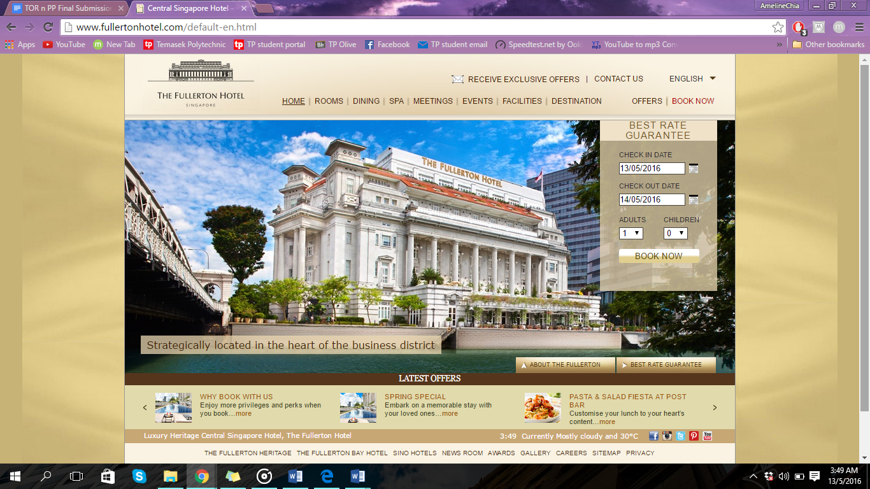

*Figure 1 – Fullerton Hotel Home web page*

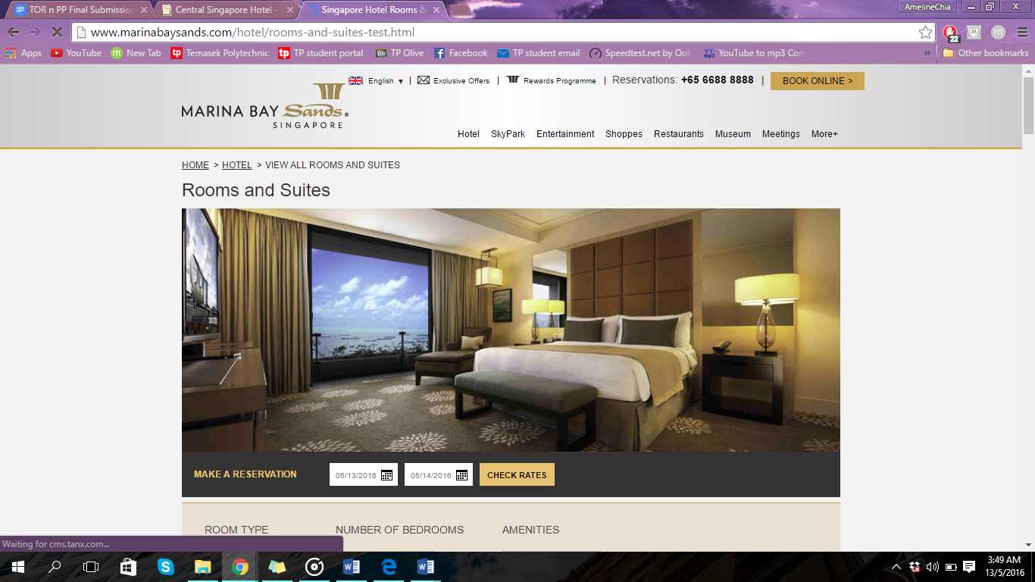

*Figure 2 – Marina Bay Hotel Home web page*

## **Approach and Methodology of the Project**

Our team would be adapting the incremental models for the project. This is because it generates working software quickly and early during the software life cycle. It is also easier to test and debug during a small iteration and it is less costly to change scope and requirements. It also requires a lower initial delivery cost and it is also easier to manage risk because risky pieces are identified and handled during iteration

One of the problems that we might face would be is lack of funds as it will be very costly and the clients might not have enough funds to pay for the software and the model will need a clear description and information of the whole system before it can be broken down and built incrementally. To solve this problem, we will try to cut cost so that the clients would have enough funds to pay for the system and our team will plan precisely and work our plan to ensure we can have a clear understanding of the whole system.

# **Project Plan**

## **Introduction**

### **Objectives and scope of the project**

We are tasked to build a hotel management system for Delonix Regia managed by Mr. and Mrs. Wang. It will allow the management of reservations, rates, check-in and check-out, housekeeping and online bookings. The listed features above will be implemented because it will serve the basic needs of a hotel.

Furthermore, the hotel management system must be properly secured to prevent unauthorized users from gaining access that may affect the hotel credibility to protect sensitive information provided by their guests.

Reservations

This feature allows the receptionist to check for room availability, type and status. It will be able to save guest details such as name to the system so that returning guest details can be automatically filled in the reservation screen. Furthermore, it may also store guest requests. The receptionist will also be able to search for reservations by id.

Rates

This feature will store all the special pricing for the hotel rooms such as promotions. For example, the management can provide special rates for holiday or other purposes like family promotion. Long-term rates can also be managed by this feature.

Online bookings

This feature will integrate the booking module on the hotel website and it will allow the guest to enter their intended check-in and checkout dates along with their preferred room. They will be able to find out the room availability and price in real time. The system will also provide the confirmation of booking to the guest once they completed the booking.

Check-in

This feature will automatically allocate the rooms to guest who wanted to check-in for the day. It will collect the room deposits in advance from the guests allowing the receptionist to pass the room cards to them.

Check-out

This feature will print the invoices of the guest’s stay in the hotel. It will have the option to charge the guest with extra charge for late check-out. Guest will make payments at check-out and this feature will support payment. It will also print receipts for the guest.

Housekeeping

This feature is able to list down the check-ins, checkouts or other repair and maintenance required. It will generate the daily task lists for housekeepers. If there is any need for repair and maintenance, it can be recorded or reported to the system.

User Management

This feature is able to enable guest to create, update, delete and retrieve their account.

The project is expected to deliver a fully-functional and a wide range of features of a hotel management system. It must also have equipped with security features that protects the sensitive data from unauthorized users.

### **Assumptions and constraints**

|  |  |
| --- | --- |
| Name | Assumptions |
| Muhammad Azrul B Mohd Sanif | 1. I assumed that the room status will indicate if the room is available, reserved, checked-in, checked-out and blocked. 2. I may also assume that the guests will have to provide deposits before receiving their room cards during check-in. |
| Ameline | 1. I assumed that the Delonix Regia have investors to aid and support them financially 2. I assumed that Delonix Regia’s have no legal conflicts 3. I assumed that the guest will make their reservations and bookings through online means 4. I assumed that there will not be any malfunctions of the software chosen 5. I assumed that the hardware equipment that have been picked are sold in Singapore, and it is in the markets |
| Douglas Tan Jin Kun | 1. I assume that the clients would have enough funds to pay for the software 2. I also assume the duration of the project schedule as i am not sure of how to allocate the duration properly |

Time constraints:

We may face difficulties to meet the deadlines for the features to be completed because we are not able to assign the exact total number of days required to complete the features. It may requires more time and eventually, other features have to be delayed.

### **Definitions and acronyms**

We understand that the project plan is to guide us to effectively control and execute the project. It is the most vital ingredient of a successful project that we need to have when we would like to start on a business project.

Documentation is important to keep track of the project requirements, scheduling and budget summary. If we are not able to document all the details properly, it may have serious effects that may affect our ability to provide our client with an effective hotel management system.

## **Roles and responsibilities**

There are at least eight features for the hotel management system. We will distribute the workload equally among us.

Azrul will be responsible for the reservations and housekeeping features of the hotel management system. So he will need to develop the features that the hotel staff will manage. The receptionist will look into the reservation system while the housekeepers will look into the housekeeping system so that they can find out their schedule.

Douglas will take responsibility for the system security features and online booking module. He will ensure that the hotel management system is highly secured and he will look after the online reservations system. This feature will allow the hotel guest to book their rooms online.

Ameline will be responsible for the check-in, check-out and user management for the hotel management system. She will ensure the customer satisfaction of the hotel management system.

We may need to work together on some of the key features such as security features. It may require more people to be involved in implementing it. All of us will also be working together for user management and rates.

## **Estimates and project schedule**

### **Work breakdown structure**

|  |  |  |  |
| --- | --- | --- | --- |
| Task No. | Task Name | Duration | Resources |
| 1 | **Project Discussion** | 4 | Ameline, Douglas, Azrul |
|  | **1. Security Feature** |  |  |
|  | Planning and Requirement Analysis | 1 | Douglas |
|  | Defining Requirements | 1 | Douglas |
|  | Design | 1 | Douglas |
|  | Development | 2 | Douglas |
|  | Testing | 1 | Douglas |
|  |  |  |  |
|  | **2. Online Booking Feature** |  |  |
|  | Planning and Requirement Analysis | 1 | Douglas |
|  | Defining Requirements | 1 | Douglas |
|  | Design | 1 | Douglas |
|  | Development | 2 | Douglas |
|  | Testing | 1 | Douglas |
|  |  |  |  |
|  | **3. Reservations Features** |  |  |
|  | Planning and Requirement Analysis | 1 | Azrul |
|  | Defining Requirements | 1 | Azrul |
|  | Design | 1 | Azrul |
|  | Development | 2 | Azrul |
|  | Testing | 1 | Azrul |
|  |  |  |  |
|  | **4. Housekeeping Features** |  |  |
|  | Planning and Requirement Analysis | 1 | Azrul |
|  | Defining Requirements | 1 | Azrul |
|  | Design | 1 | Azrul |
|  | Development | 2 | Azrul |
|  | Testing | 1 | Azrul |
|  |  |  |  |
|  | **5. Check-In Features** |  |  |
|  | Planning and Requirement Analysis | 1 | Ameline |
|  | Defining Requirements | 1 | Ameline |
|  | Design | 1 | Ameline |
|  | Development | 2 | Ameline |
|  | Testing | 1 | Ameline |
|  |  |  |  |
|  | **6. Check-Out Features** |  |  |
|  | Planning and Requirement Analysis | 1 | Ameline |
|  | Defining Requirements | 1 | Ameline |
|  | Design | 1 | Ameline |
|  | Development | 2 | Ameline |
|  | Testing | 1 | Ameline |
|  |  |  |  |
|  | **7. Rates Features** |  |  |
|  | Planning and Requirement Analysis | 1 | Ameline, Douglas, Azrul |
|  | Defining Requirements | 1 | Ameline, Douglas, Azrul |
|  | Design | 1 | Ameline, Douglas, Azrul |
|  | Development | 2 | Ameline, Douglas, Azrul |
|  | Testing | 1 | Ameline, Douglas, Azrul |
|  |  |  |  |
|  | **8. User Management Features** |  |  |
|  | Planning and Requirement Analysis | 1 | Ameline, Douglas, Azrul |
|  | Defining Requirements | 1 | Ameline, Douglas, Azrul |
|  | Design | 1 | Ameline, Douglas, Azrul |
|  | Development | 2 | Ameline, Douglas, Azrul |
|  | Testing | 1 | Ameline, Douglas, Azrul |
|  |  |  |  |
|  | Overall Software Testing | 2 | Ameline, Douglas, Azrul |
|  | Deployment | 1 | Ameline, Douglas, Azrul |
|  | Presentation to the clients | 1 | Ameline, Douglas, Azrul |
|  | Mass Product Release | 0 |  |

### **Project Schedule**

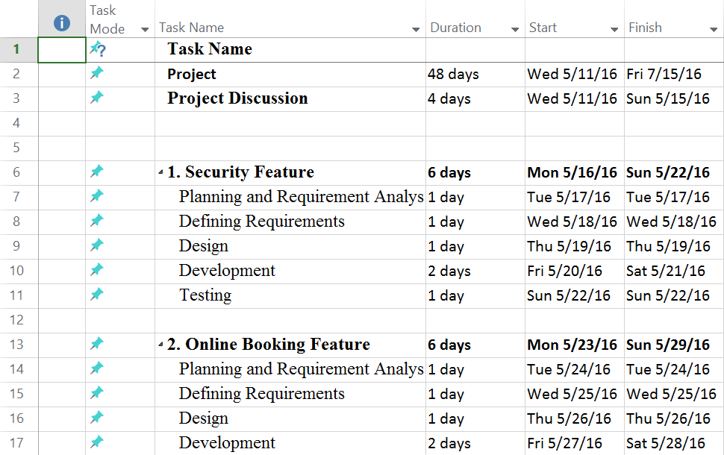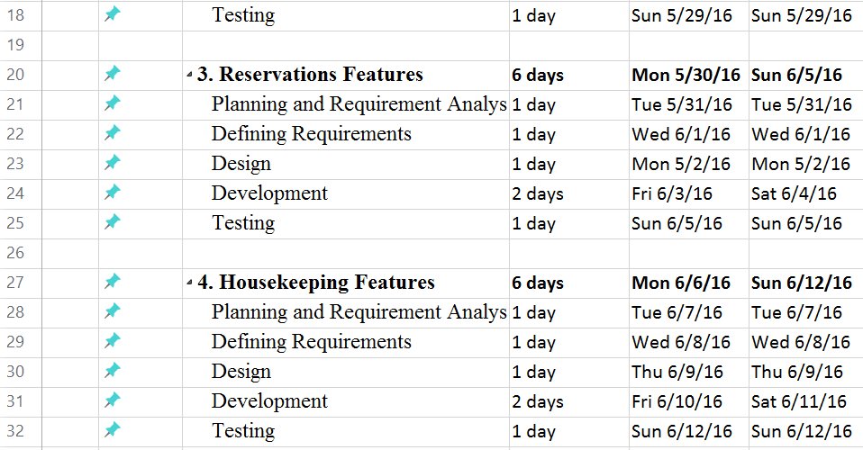

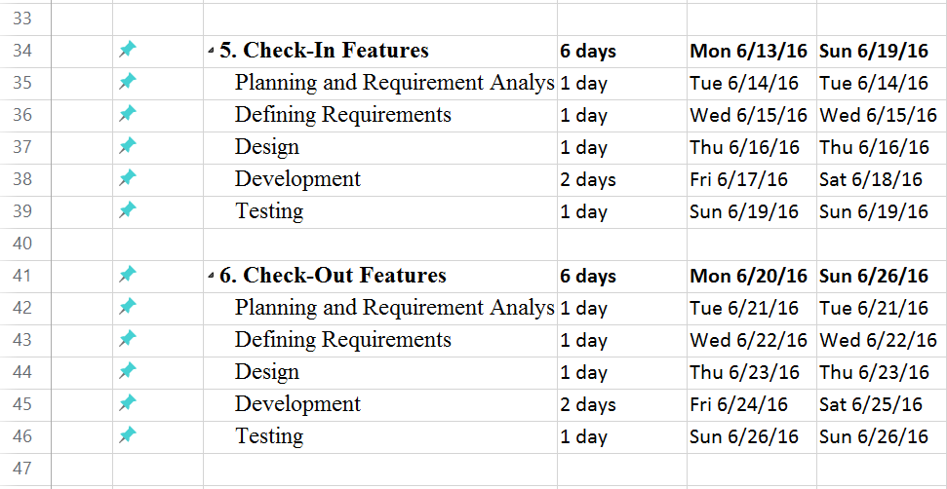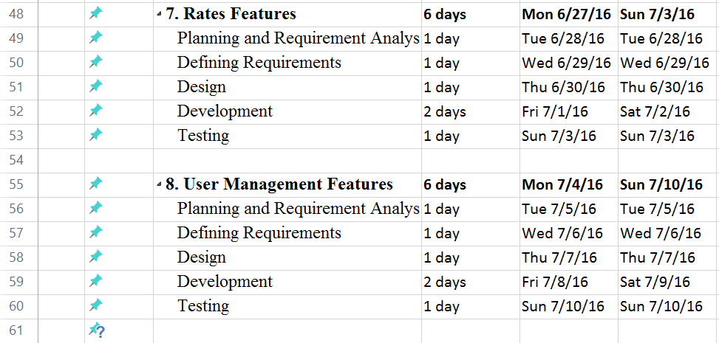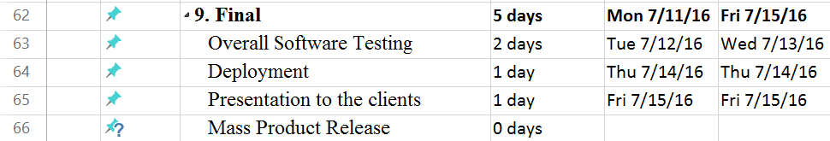

*Figure 3 – Microsoft Project Scheduling*

### **Budget Summary**

In the hotel, the expenses budget will be spilt into 3 main categories. Under each category, the budget are meant for different purposes. The different categories are:

* Man-Power expenses: This budget will be used to pay the employees who are working on the project for 8 weeks. The budget that we proposed as the salary for the employers is SGD$23,829. On average, a software developer can earn a decent and average salary of SGD$47,658 per year. Hence, we used that figure as the benchmark to estimate and come out with an appropriate salary for the employees who are working on the project.
* Software expenses: This budget will be used to make payments for software systems that will be implemented to the project. The budget is use for software systems such as:
  + Operating system: Windows 10 (SGD $162.89 )

Latest operating system by Microsoft Windows

User-friendly and easy to use interface for Delonix Regia employees

Good and improved security management compared to other operating system

Authentication through cloud-base Azure Active directory. This feature enable Delonix Regia employees access to thousands of cloud SaaS applications such as Office 365, DropBox and Concur. Furthermore, with authentication implemented together with cloud-base Azure Active directory; it help secure the information, cut costs on hardware security systems and help assure Delonix Regia that their company goals are met.

* + Database software: SQL Server Management Studio (Free)

Allow Delonix Regia to manage analysis services objects, such as performing back-ups and processing objects

Enables Delonix Regia to manage packages and monitor running packages

Easy and manageable reporting services features that allow Delonix Regia to administer the server and databases, and manage roles and jobs.

* + Anti-virus software: AVIRA (Free)

Downloadable from AVIRA official website

Prevents infections from viruses, worms and Trojans

Detects other threats other than viruses

Notification of suspicious code or viruses act will be displayed

Protects againsts spyware, adware and keeps Delonix Regia systems safe from hidden malware.

Identify and protects theft attacks, so Delonix Regia’s guests can make reservations and bookings safely on the software.

* Hardware expenses: This budget will be used to make payments for hardware equipment that will run the software systems. The budget is use for hardware systems such as:
  + Desktop: Dell XPS One 27 (SGD $2099.00)

Touch screen capabilities that allow Delonix Regia to cut cost on purchasing a keyboard

2550 x 1440 resolution

78% more pixels overall and 33% more pixels per inch

6 USB 3.0 ports that sync devices

Not much wiring needed to power the system. It is a clutter-free desktop

New 4th Generation Intel Core processors

32GB SSD provides Delonix Regia expanded memory cache

1 year basic warranty

* + Server: Dell PowerEdge T20 Tower Server System (SGD 509.93)

4 x UDIMM memory

4 slots: 1 x16 (x16, G3)

1 x 16 (x4, G2)

1 x 1 (x1, G2)

1 x PCI slot

290W power

Operating system: Windows Server 2008 R2, 2012, 2012 R2

Processor: Intel Xeon E3/Intel Pentium

Quiet and compact design. Very suitable for hotel like companies such as Delonix Regia.

Data protection using software-based redundant array of independent disks. Furthermore, error correction code adds another protective layer to the data

Backup and restore with the full collaboration suite, Microsoft Windows Small Business Server

Warranty included

* + Printers: HP Colour LaserJet Enterprise M553dn (SGD $599.00)

Print speed of up to 40 ppm (black and colour)

Auto duplex printing

2 paper trays

Warranty included

|  |  |
| --- | --- |
| **Expense Budgeting** | **Project Duration (Week 1 - Week 8)** |
| $ |
| Man-Power | 23,829 |
| Software | 162.89 |
| Hardware | 3207.93 |
| **Total** | **27,199.82** |

### **Risk Management Plan**

This plan documents the processes, tools, and procedures that will be used to manage and control the events that could have a negative impact on Delonix Regia’s hotel management system. This plan will address:

* Risk Identification
* Risk Assessment *(With reference to Figure 4)*
* Risk Mitigation

|  |  |  |  |
| --- | --- | --- | --- |
| **Risk Management Plan for Delonix Regia’s Hotel Management System** | | | |
| **No.** | **Risk Factor** | **Probability of Occurrence** | **Mitigation** |
| **1.** | Specifications and designs of the software are not properly defined by the end-user (Requirements Inflation) | 4C | Early and frequent meetings should be carried out with Mr Wang to clarify the details and specifications of the software |
| **2.** | Deadline of the project is not met (Inherent Schedule flaw) | 4B | Monitor each stage of the project’s development.  Keep Mr Wang updated on the progress of the project |
| **3.** | Softwares are not compatible with one another | 3A | Detailed and extensive research should be done on each specified software |
| **4.** | The project runs over the estimated budget | 3C | Specify and properly estimate the budget before starting on the project |
| **5.** | The company do not have the financial stability to afford the project during development | 5A | Early and frequent meeting should be held to layout necessary discussions before the project is carried out |
| **6.** | Unforeseen circumstances happen, such as power shortage | 4B | Discussions should be made early on necessary extension of deadline if unforeseen circumstance happens |

*Figure 3 – Risk Management Plan for Delonix Regia Hotel Management System*

|  |  |  |  |  |  |  |
| --- | --- | --- | --- | --- | --- | --- |
| **Probability of Occurrence** | | **Catastrophic** | **Critical** | **Moderate** | **Minor** | **Negligible** |
| **Definition** | **Value** | **(A)** | **(B)** | **(C)** | **(D)** | **(E)** |
| Frequent | 5 | 5A | 5B | 5C | 5D | 5E |
| Likely | 4 | 4A | 4B | 4C | 4D | 4E |
| Occasional | 3 | 3A | 3B | 3C | 3D | 3E |
| Seldom | 2 | 2A | 2B | 2C | 2D | 2E |
| Improbable | 1 | 1A | 1B | 1C | 1D | 1E |

*Figure 3 – Risk Assessment Level*

Risk Levels:

* Risk is High for values 5A, 5B, 5C, 4A, 4B, 3A
* Risk is Medium High for values 5D, 5E, 4C, 3B, 3C, 2A, 2B
* Risk is Medium Low for values 4D, 4E, 3D, 2C, 1A, 1B
* Risk is Low for values 3E, 2D, 2E, 1C, 1D, 1E

# **References**

Julie Davoren, D. M. (n.d.). *The Three Fundamental Roles of Information Systems in Business*. Retrieved from smallbusiness,chron : http://smallbusiness.chron.com/three-fundamental-roles-information-systems-business-23681.html

*What are the different features of any hotel management software?* (n.d.). Retrieved from Quora: https://www.quora.com/What-are-the-different-features-of-any-hotel-management-software

*What is Incremental model- advantages, disadvantages and when to use it?* (n.d.). Retrieved from ISTQB EXAM CERTIFICATION: http://istqbexamcertification.com/what-is-incremental-model-advantages-disadvantages-and-when-to-use-it/

*Project Management: How to Define Project Constraints* (n.d.). Retrieved from Dummies: http://m.dummies.com/how-to/content/project-management-how-to-define-project-constrain.html

Luxury Heritage Central Singapore Hotel, The Fullerton Hotel. (n.d.). Retrieved May 12, 2016, from <http://www.fullertonhotel.com/default-en.html>

STAY IN THE MOST SPECTACULAR HOTEL IN SINGAPORE! (n.d.). Retrieved May 12, 2016, from <https://www.marinabaysands.com/>

Dell updates the awesome XPS 27 with new CPUs. (n.d.). Retrieved May 12, 2016, from <http://www.cnet.com/products/dell-xps-one-27-all-in-one-desktop/>